Differences among genders in various types of bullying:
Bullying

Mr. Shields
I. E Weldon Secondary School

Table of Contents

Abstract pg. 3

Introduction pg. 4

Literature Review pgs. 4-7

Method of Research pgs. 7-9

Results of Research pgs. 9-16

Interpretation of Data pgs. 16-18

Conclusion pg. 18

Implications pg. 19

References pg. 19-20

Appendix pg. 20-22

Abstract

This study was created in purpose to discover trends in local bullying and to draw conclusions that can be interpreted for the better of society. Males in general, particularly at I.E Weldon Secondary School engage in physical bullying whereas females engage in online harassment and bullying that involves verbal abuse is commonly used between both genders. This report explains the various types of bullying, physical, verbal, and cyber and draws connections to exterior sources that are revealed in the literature review. This report contains a field study that was conducted in the forms of an observation and a survey. Participants from around the I.E Weldon community were observed and questioned through the forms of relevant questions from an online survey. The field study reveals indications of local issues and furthers the study into the possible issues of the near future.

Key Words: physical bullying, online harassment, verbal bullying verbal abuse, cyber bullying, and issues.

Introduction

The concept of bullying seems to be an evolving issue over the years. It is important to recognize and understand a clear conception of bullying as it comes in many forms. Bullying can be caused by a superior strength or influence to intimidate someone. Bullying can also come in the form of cyber in that the superior force or influence is taken place online. Harassment of any sort can be considered bullying. Bullying happens more than one may think and it is important to recognize the patterns and trends of bullies in general. Bullying appears to take place upon adolescents. Bullying is becoming a trend upon teenagers in a global context. The hypothesis is that males in general, particularly at I.E Weldon Secondary School engage in physical bullying whereas females engage in online harassment and bullying that evolves verbal abuse is commonly used between both genders. Throughout this report concepts of bullying will be discussed and conclusions will be reached. This paper will benefit those who are studying bullying and those who are of academic interest.

Literature Review

The academic sources that have been used to benefit this report are of importance in that trends and fads exist within. The four sources, A Culture of Violence, Kids Hurting Kids: Bullies in the Schoolyard, and Cyberbullying and Online Harassment: Conceptualizing the Victimization of Adolescent Girls connect to the topics of physical, verbal and cyber bullying. Schools of thought from other types of theories will be applied.
As expressed in A Culture of Violence physical bullying is defined as “hitting, kicking, pushing and/or taking personal belongings.” (2004) The source concludes that direct bullying includes physical attacks that are directly meant to harm someone specifically. The source also implies that males participate in physical bullying more than the other types of bullying. Kids Hurting Kids suggests, “One out of every four schoolchildren endures some type of bullying in a direct form.” (2001) The academic article Bullying advocates that males have a “targeted” (2012) person that they tend to bully. These three sources connect in the way that physical bullying can be linked towards males and it can be suggested that males are associated with direct bullying. This can be connected to the association theory by Edwin Sutherland in the way that through interaction with others, individuals learn values, attitudes and techniques. These articles suggest that males are more physically violent in a bullying manner and can be associated with physical bullying.
As defined in A Culture of Violence verbal bullying is defined as “taunting, malicious teasing, name calling and/or making threats.” (2004) This source also states that “verbal attacks and harassment are considered indirect” (2004) bullying. The source suggests that both males and females equally engage in verbal abuse. Kids Hurting Kids states, “as a society encourages competition and dominance, issues of right and wrong are being blurred.” (2001) The source Bullying suggests that females “participate in bullying through pier groups” (2012) through direct and indirect forms. The source also implies that females tend to spread “hurtful information” (2012) about someone, otherwise known as gossiping. The term hyperculture can be connected in the way that the speed of technology is processing so rapid that issues of right and wrong are being blurred. This term can be connect to verbal bullying and bullying in general in the sense that children being born into a world so technically advanced that issues of right and wrong are occurring as a problem. Children are now introduced to technology at a young age, which suggests forms of bullying.
Cyber Bullying and Online Harassment defines cyber bullying as involving text messages or anything other on screen source that includes “threats or any sort of harassment.” (2010) A Culture of Violence suggests that cyber bullying can be connected to the psychological and emotional category, which includes “spreading rumors, manipulating social relationships, or engaging in social exclusion, extortion, or intimidation.” (2004) The source also advocates that females tend to engage in cyber bullying more than males do. Kids Hurting kids says, “society has allowed bullying to become acceptable.” (2001) The source also outlines, “bullying exists in every culture regardless of any ethnical standing.” Cyber Bullying and Online Harassment suggests that females engage in cyber bullying more than males do. Cyber bullying can be connected to the theories of imaginary audience, personal fable, technosis and egocentrism. The theories connect in the way of an individual believing that they are always the center of someone else’s attention. The idea of a personal drama unfolding before an imaginary audience can connect to the theory of imaginary audience. The overblown dependency and/or attachment to technology can possibly be the result of cyber bullying. People who have a heightened self-awareness and self-conscience can also be the cause of cyber bullying. The world of social media and the people using it have confidence behind screen, which allows them to see the world only from their perspective.

Methods of Research
Observation
Participants
Participants in this portion of the study included 20 I.E Weldon Secondary School Students. Participants involved 10 males and 10 females. All participants in this student were of a random selection of people who were engaging in some form of bullying.
Materials
Materials that subsist in the field study are that of an observation chart for five days of the week. No verbal communication was used to prompt bullying occurrences.
Procedure
The observation took place in various locations around I.E Weldon Secondary School. The purpose of the observation was to find out whether males engaged in physical bullying and if females engaged in cyber bully and if verbal bullying was commonly used upon both genders. I simply sat and observed behavior from students that were wondering and hanging out around the area. Instances of physical, verbal and cyber bullying were noted. No interactions with students were made unless the students engaged in conversation. The first portion of the observation field study I was specifically looking for males that were engaging in physical behavior. For the second portion I searched around on social media (Twitter, Facebook, Instagram) looking at instances of cyber bullying. Instances of both forms were noted on the same observation chart. The independent variable was that I could not change how participants acted, which allowed the observation to be honest. I also could not change who participated in online bullying even though I relied on females to have more instances.

Survey
Participants
Participants in the study included 60 random Internet users who are from I.E Weldon Secondary School. Participants included 42 females and 14 males. All participants were random volunteers.
Materials
An online survey was created and posted/shared to online networks such as Twitter and Facebook. The survey asked various questions about online activity that suggested cyberbullying, physical abuse and verbal bullying instances.
Procedure
The survey was created on November 15th, 2015. The survey was posted to various social media platforms. The survey entailed a brief description of exactly what bullying was so that there was no confusion to participants. The survey was created in hope to discover that males engage in physical bully whereas females engage in cyber bullying and that verbal bullying was common upon both genders, which can be considered as a dependent variable. The survey was first shared on November 18th, 2015 to Facebook, which received 20 replies. The next day, November 19th, 2015 the survey was posted again to Facebook and to Twitter, which received another 20 replies. The survey was shared one last time on December 5th, 2015 and received another 20 replies. The independent variables that occurred within the process were the amount of people who did the survey; it was hard to control how many males and females completed it. The survey would have worked better if there were an equal amount of both male and females. Since the survey was online it was difficult to control if it was just I.E Weldon students who filled it out however, it was interesting to know the communities input as a whole. The survey was controlled by the questions that were asked in that they could not be changed. Participants were to select the options that I made and not input answers by paragraphs, which was controlled.

Results of Research
The following graphs are from the survey that was created to discover instances of bullying among those in the community of I.E Weldon Secondary School.
Figure 1
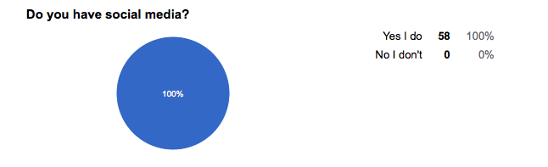

This graph reveals that 100% of participants have some form of social media.

Figure 2
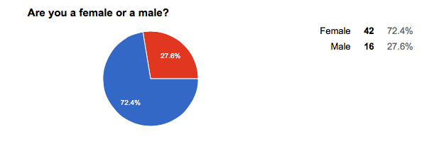
This graph reveals the number of males and females of participants.
42 Females
16 Males
Figure 3
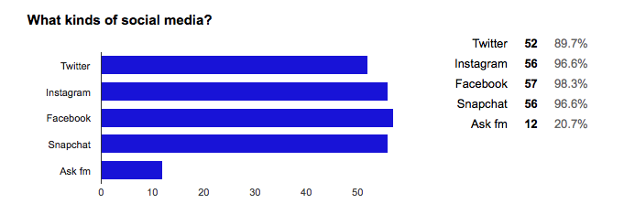

This graph displays the various types of social media that participants have.
52 participants have Twitter
56 participants have Instagram
57 participants have Facebook
56 participants have Snapchat
12 participants have Ask fm

Figure 4
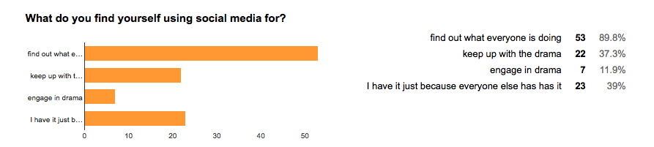

89% said that they have social media to find out what everyone is doing, 37% said that they have it to keep up with the drama, 11% said that they have it to engage in social media and the remanding 39% of participants said that they have it because everyone else has it.

Figure 5
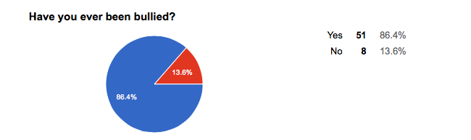

86 % of participants have been bullied in some form.
13% of participants claim that they have never been bullied.

Figure 6
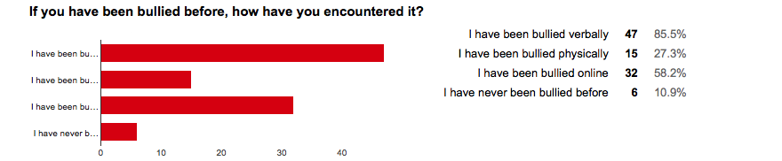

Figure 7
47 participants said that they have been bullied verbally.
15 participants said that they have been bullied physically.
32 participants said that they have been bullied online, cyber bullying.

Figure 8
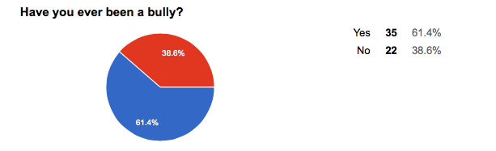

35 participants admitted to participating in forms of bullying. 22 participants declined that they have ever been a bully.

Figure 9

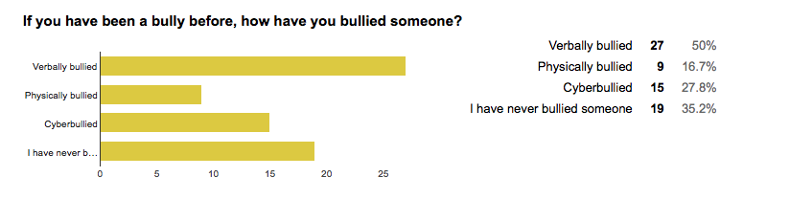

This graph outlines the forms of bullying that was used by the bully participants.
50% verbally bullied.
16% physically bullied.
27% cyber bullied.
35% said that they have never bullied someone before.

Figure 10

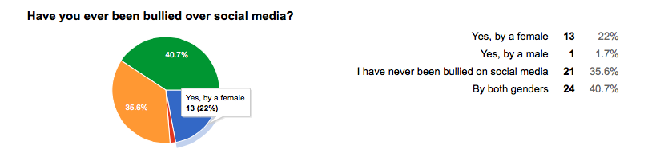

This graph determines the sources of bullying that the participants have encountered through social media. 22% said that a female has bullied them, 1 % said that a male has bullied them over social media, 35% claim that they have never been bullied on social media and 40% of participants suggest that they have been bullied on social media by both genders.

Figure 11

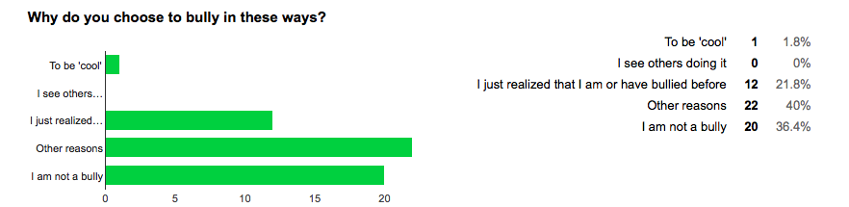

This graph displays why bullies choose to bully.
1 person said to be ‘cool’.
No one said that they see other people doing it.
12 people said that they just realized that they are or have been a bully.
22 participants said that they had other reasons for bullying.
20 participants said that they are not a bully.

Figure 12
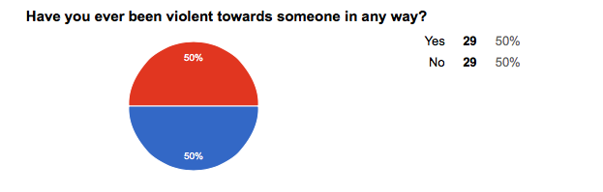
This graph represents the amount of people that have experienced violence.
50% said that they have and 50% said that they have not experienced violence.

Figure 13
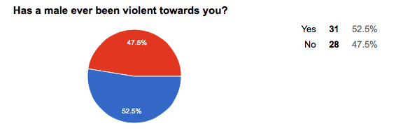

31 participants revealed that males have been violent towards them and the remanding 28 people said that males have no been violent towards them.

Figure 14
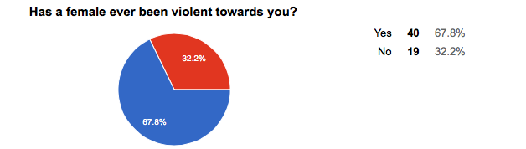

40 participants said that females have been violent towards them and 19 people said that females have not been violent towards them.

Figure 15
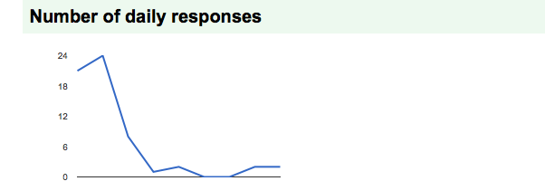

This graph displays the number of daily responses.

The following charts are from the observation section of the field study that was created to find instances of bullying. There were 10 participants of each gender each day. Instances of cyber bullying will be searched for online and verbal and physical bullying will be searched for in person.

Day 1- November 30th, 2015
Where | When | Grade if known | Male | Female | Physical  Bullying | Verbal Bullying | Cyber Bullying | Outcome
Atrium  I.E Weldon | 11:00  Am  Nov. 30/15 | 9: 5  10: 5  11:5  12:5 | 10 | 10 | Female:  Male:  5 | Female:  4  Male:  3 | Female:  6  Male:  2 | Female:  Verbal bullying  Male:  Verbal & physical abuse

Day 2- December 1st, 2015

Where | When | Grade if known | Male | Female | Physical Bullying | Verbal Bullying | Cyber Bullying | Outcome
Back Hall  I.E Weldon | 11:00  Am  Dec. 1/15 | 9: 5  10: 5  11:5  12:5 | 10 | 10 | Female:  1  Male:  4 | Female:  4  Male:  4 | Female:  5  Male:  1 | Female:  Verbal abuse  Male:  Common use in Verbal

Day 3- December 2nd, 2015

Where | When | Grade if known | Male | Female | Physical Bullying | Verbal Bullying | Cyber Bullying | Outcome
‘Emo’ Hall  I.E Weldon | 11:00  Am  Dec.  2/15 | 9:  10:  11:  12: | 10 | 10 | Female:  2  Male:  5 | Female:  4  Male:  2 | Female:  4  Male:  3 | Female:  Cyber & Verbal  Male:  Physical

Day 4- December 3rd, 2015

Where | When | Grade if known | Male | Female | Physical Bullying | Verbal Bullying | Cyber Bullying | Outcome
‘Geo’  Hall  I.E Weldon | 11:00  Am  Dec. 3/15 | 9:5  10:5  11:5  12: 5 | 10 | 10 | Female:  1  Male:  4 | Female:  4  Male:  5 | Female:  5  Male:  1 | Female:  Cyber  Male:  Verbal insults

Day 5- December 4th, 2015

Where | When | Grade if known | Male | Female | Physical Bullying | Verbal Bullying | Cyber Bullying | Outcome
Library  Hall  I.E Weldon | 11:00  Dec. 4/15 | 9:  10:  11:  12: | 10 | 10 | Female:  1  Male:  2 | Female:  3  Male:  5 | Female:  6  Male: 3 | Female:  Cyber  Male: Verbal

Interpretation of Data

The interpretation of the data was collected in the form of a survey and an observation. Results will be revealed and discussed within (see figures 1-15 and Days 1-5). There were 42 (72.4 %) females and 16 males (27.6%) who completed the survey. This can be assumed that females use social media more often than males. All participants (100%) said that they have social media in some form, 52 Twitter users, 56 Instagram users, 57 Facebook users, 56 Snapchat users and 12 (20.7 %) Ask fm users. 53 users of social media say that they have it because they have a want to find out what is going on while others have it to keep up with drama and possibly engage in it. This can relate to the idea that society, as a whole is more involved in social media than ever before. The fact that all participants have some form of social media suggests that our society may be an example of the technosis theory. 86.4 % of participants said that they have been bullied in some form while the remaining 13.6% said that they have not been bullied in any form. 61% of participants revealed that they have been a bully and 38% said that they have never been a bully before. This reveals that society has truly allowed bullying to become acceptable and that more people are participating in bullying behaviors. The Social Learning theory by Albert Bandura can connect to this statement in that all behavior is learned and then modeled. The theory relates in the sense that bullying has been taught to the younger of society and then modeled. The Social Learning theory also suggests that if bullying is still prevalent in society then the younger of society will continue to learn behaviors and teach such behaviors to others. The bullies that confessed their behavior revealed that instances of verbal, physical and cyber bullying was of presence in their behavior. 27 participants said they have verbally bullied, 9 people said that they have physically bullied, and 15 participants said that they have Cyberbullied. This reveals that verbal bullying is the most common of the types. 12 participants that admitted to being bullies suggested that through the course of the survey they realized they were bullies and 22 others said that there were other reasons pertaining to why they bullied. The participants that said that they had other reasons for bullying suggest a wide variety of limitations. It leaves a large variety of possibilities as to why bullying occurs and conclusions cannot be made. 40% of victims of bullying said that they have been bullied by both genders on social media, 22% said that they have been bullied by a female, 1% said that they have been bullied by a male and 35% of victims said that they have never been bullied on social media. This relates to the hypothesis of females tending to be perpetrator of cyber bullying however, participants said that males also were bullies of social media. 29 participants said that they have been violent towards someone in some kind of form and the remanding 29 participants said that they have not been violent towards anyone in any way. 52% said that males have been violent towards them and 47% said that males have not been violent towards them. This suggests of male dominance, however, 40 participants said that females have been violent towards them and 67% said that females have not been violent towards them in any way. Violence from both genders seems to be becoming a trend within our society.
Conclusion

Bullying is prevalent in the sense that it has many issues in our modern society. The survey and observations reveal that with the hyperculture of technology bullying is becoming a bigger issue than once thought. It is important to recognize and act upon the issues. Although only 16 males were surveyed, it is found as a trend through evidence from the survey and observations that males are violent and use violence in bullying. It is reported that females also use some form of violence when bullying. The issue of cyber bullying is not just among females. With results from the survey, it can be concluded that both genders equally participate in online bullying. The most common form of bullying is verbal in that 50% of participator’s reported that they themselves have bullied in this form. 85% of the participant’s revealed that someone through the form of verbal abuse has bullied them. The results from the observation reveal that students at I.E Weldon often use degrading and malicious words to harass those among them. It can be concluded that physical, verbal and cyber bullying are all equally commonly used upon both genders. The hypothesis of males engaging in physical bullying and females engaging in cyber bullying is proved otherwise in that all forms of bullying are used equally upon both genders.

Implications

As there are three types of bullying, there are many issues within. The Evolutionary theory proves that through time issues like bullying will be become more complex and an even bigger issue than it already is. Many bullying instances lead into suicidal thoughts and depression, which is a huge issue in our modern society. Bullying is a form of deviance however; bullying is becoming a behavior that people conform to. As stated in Kids Hurting Kids “bullying is a bigger issue than one may think.” (2001) If society does not recognize and act upon the issues of bullying, it will become an even bigger issue that will not be able to be controlled. As technology progresses and allows ample opportunities through sites, cyber bullying will only become more common upon users. Physical and verbal bullying needs to be addressed in that the younger people of society are learning behaviors of such. Since generation X has allowed bullying to become acceptable, generations Y and Z need to adapt to solutions. Neo-Marxism provides the statement of ‘power gives influence’ and if those of power and hierarchy do not give influence and solutions to the issue, bullying will become out of control.

References

“A Culture of Violence?: Current Topics of Special Interest.” Web 9. November 2015. Youth Violence, Crime, and Gangs: Children at Risk. Kathleen Edgar. 2004 Ed. Detroit: Gale, 2004. Information Plus Reference Series. Canada in Context.

A.S Popkin, H. (2007). Cyberbullying Really Is That Bad.

Beron, Tanya. Bullying: What are the Differences Between Boys and Girls? (2012, January 24.) Retrieved November 15, 2015.

Burgess-Proctor, A., Patchin, J.W &Hinduja, S. (2010). Cyberbullying and online harassment: Conceptualizing the victimization of adolescent girls. V. Garcia and J. Clifford [Eds.]. Female crime victims: Reality reconsidered. Upper Saddle River, NJ: Prentice Hall.

Gerdes, L. (2012). Cyberbullying. Detroit: Greenhaven Press.

Hamilton, J. (2008). Bullying and hazing. Detroit: Greenhaven Press.

Hughes, J. (2007). Whatever Schools Say, Bullying Still Flourishes. The Age.

Smith-Heavenrich, Sue. (2001) “Kids Hurting Kids: Bullies in the Schoolyard.” Introducing Issues with Opposing Viewpoints. USA: Greenhaven Press.

Appendix
Appendix A

Survey

Bullying comes in many forms. Keep in mind that a bully is not only someone who uses superior strength or influence to intimidate someone but also bullies can use social media as a way to bully, this is also known as cyberbullying. Harassment of many sorts can be considered bullying. ‬‬
If you ever encountered someone "subtweeting" or posting something directed at you it is a form of bullying. ‬

Are you a female or a male?
Female
- Male
Do you have social media?
Yes I do
- No I don't

What kinds of social media?
Check all that apply
- Twitter
- Instagram
- Facebook
- Snapchat
- Ask fm

What do you find yourself using social media for?
I use social media to.. (Check all that apply)
- Find out what everyone is doing
- Keep up with the drama
- Engage in drama
- I have it just because everyone else has it

Have you ever been bullied?
Yes
- No
If you have been bullied before, how have you encountered it?
Check all that apply
- I have been bullied verbally
- I have been bullied physically
- I have been bullied online
- I have never been bullied before

Have you ever been a bully?
Yes
- No

If you have been a bully before, how have you bullied someone?
Check all that apply
- Verbally bullied
- Physically bullied
- Cyber bullied
- I have never bullied someone

Have you ever been bullied over social media?
Yes, by a female
- Yes, by a male
- I have never been bullied on social media
- By both genders

Why do you choose to bully in these ways?
Check all that apply
- To be 'cool'
- I see others doing it
- I just realized that I am or have bullied before
- Other reasons
- I am not a bully

Have you ever been violent towards someone in any way?
Yes
- No
Has a male ever been violent towards you?
Yes
- No
Has a female ever been violent towards you?
Yes
- No

Appendix B
Observation

Where | When | Grade (If known) | Male | Female | Physical Bullying | Verbal  Bullying | Cyber  Bullying | Outcome

